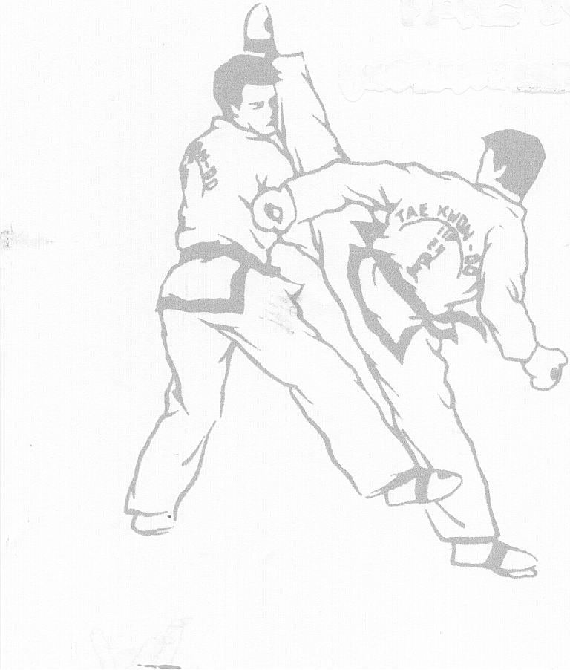

2nd June 2012

8th Portuguese Open

Sport Venue Bombeiros Voluntários de Loures






www.itfportugal.org
Date

Saturday, the 2nd of June, 2012
Place
Loures Lisbon (6 km from the airport)

Sport venue Pavilhão Gimnodesportivo dos Bombeiros Voluntários de Loures
Guilherme Henrique Soromenho street
GPS - 38°49'40.05"N 9°10'0.26"W

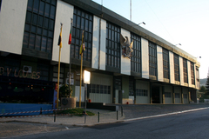

Transportation to the venue can be arranged by the organization if necessary.

Organizer
I.T.F. PORTUGAL Mr. Armando Ribeiro
E-mail i.t.f.portugal@iname.com
Telephone +351 966 403 603

Fees
- 15 € - kids competitors
- 20 € - junior and senior competitors

Send Application Forms To
i.t.f.portugal@iname.com

If you need help or information concerning the accommodations (price and location) please contact us to the same e-mail.

The deadline to send the application forms is the 18th of May, 2012

Competition Events, Divisions & Categories – Pattern & Sparring

Divisions and Classes

- There are categories/divisions for kids, juniors and seniors;
- They are divided in kup/degree and weight for juniors and seniors;
- For kids they are divided in kup/degree, height and weight;
- All competitors must have full insurance cover;
- Divisions will be fused if there not enough competitors in a division;
- Competitors must wear approved hand and foot equipment;
- All competitors must wear red or blue headgear during sparing.

Coaches
Coaches are allowed according to the following schedule :

- 1-2 coaches from 1 to 10 competitors;
- 1-3 coaches from 11 to 20 competitors;
- 1-4 coaches from 21 competitors or more.

Competition Categories

Kids male and female -14 years old
Junior male and female 15-17 years old
Senior male and female 18+ years old

Individual Patterns (Tuls)

Competitors will perform 1 optional Tul and 1 designated Tul against each other.

Sparring (times)

Kids 1 round x 1,5 minute (1 minute extra time, if the draw remains the golden point will decide the match)

Juniors 2 rounds x 2 minutes (2 minutes extra time, if the draw remains the golden point will decide the match)

Seniors 2 rounds x 2 minutes (2 minute extra time, if the draw remains the golden point will decide the match)

Sparring (divisions)

Kids 1º division – Red/Black Belt and up
2º division – Green/Blue Belt to Red Belt
3º division – White Belt to Green Belt

Juniors 1º division – Blue Belt and up
2º division – White Belt to Blue Belt

Seniors 1º division – Blue Belt and up
2º division – White Belt to Blue Belt

Sparring (height category)

Kids Male and Female -150 cm, -170 cm, +170 cm

Sparring (weight category)

Junior Female -50 kg, -60 kg, +60 kg
Junior Male -55 kg, -65 kg, +65 kg
Senior Female -55 kg, -65 kg, +65 kg
Senior Male -60 kg, -70 kg, +70 kg

Rules

Points, warnings, minus points and disqualifications will be decided according to I.T.F. Taekwon-Do Rules. In case of a dispute the Head referee will have the final decision.

I.T.F. Portugal reserves the right to reduce, augment or fuse divisions if needed.

Competition Timetable
Venue opens at 8:30
Weight 8:45
Opening 9:00
Competition Start 9:15
Kids Tuls 9:30
Kids Sparring 11:30
Lunch break 13:30
Venue opens at 14:00
Juniors Tuls 14:45
Juniors Sparring 16:30
Seniors Tuls 17:30
Senior Sparring 19:00

Map

GPS - 38°49'40.05"N 9°10'0.26"W
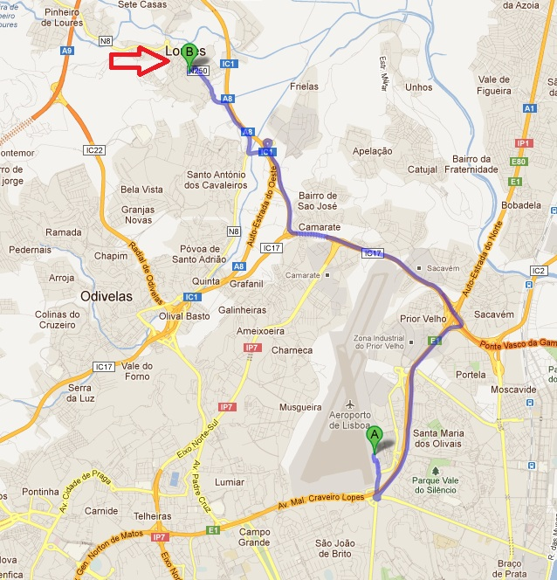

Please check the website for updates
http://www.itfportugal.org

